**Day-2 (Assignment-1)**

**SDLC Overview** - Create a one-page infographic that outlines the SDLC phases (Requirements, Design, Implementation, Testing, Deployment), highlighting the importance of each phase and how they interconnect.

**SDLC -SOFTWARE DEVELOPMENT LIFE CYCLE**

SDLC is a process followed for software building within a software organization. SDLC consists of a precise plan that describes how to develop, maintain, replace, and enhance specific software. The life cycle defines a method for improving the quality of software and the all-around development process.

**Stages of the Software Development Life Cycle:**

* Planning and Requirement Analysis

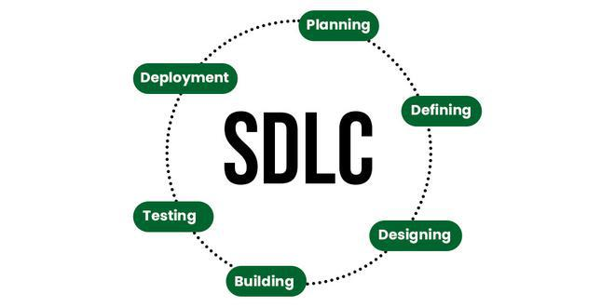

* Feasibility Study
* Design
* Coding
* Testing
* Maintenance

### **Phases of SDLC:**

#### 1. **Planning**

* **Importance:**
  + Defines the scope and purpose of the project.
  + Establishes objectives and feasibility.
  + Ensures resource allocation and budget considerations.
* **Connection:**
  + Sets the foundation for all subsequent phases.

#### 2. **Analysis**

* **Importance:**
  + Gathers detailed requirements from stakeholders.
  + Creates detailed project specifications.
  + Identifies system needs and constraints.
* **Connection:**
  + Direct input for the design phase, ensuring all requirements are addressed.

#### 3. **Design**

* **Importance:**
  + Develops architectural and detailed design of the system.
  + Specifies hardware and system requirements.
  + Creates models and prototypes.
* **Connection:**
  + Blueprint for the development phase, guiding how the system should be built.

#### 4. **Development**

* **Importance:**
  + Actual coding and building of the software.
  + Converts design documents into a functional system.
* **Connection:**
  + Produces the working software that will be tested in the next phase.

#### 5. **Testing**

* **Importance:**
  + Validates and verifies that the software meets all requirements.
  + Identifies and fixes defects and bugs.
  + Ensures the software is reliable and performs well.
* **Connection:**
  + Critical for ensuring the software is ready for deployment and use.

#### 6. **Deployment**

* **Importance:**
  + Releases the software to a production environment.
  + Installs and configures the system for end-users.
  + Provides initial user training and documentation.
* **Connection:**
  + Makes the software available for users, marking the transition to the maintenance phase.

#### 7. **Maintenance**

* **Importance:**
  + Provides ongoing support and issue resolution.
  + Implements updates and enhancements.
  + Ensures the software continues to meet user needs.
* **Connection:**
  + Continuously improves the system based on user feedback and new requirements.